**Getting Started with Google Colab**

1. To use Colab you should be logged in to your Google account. After this, click on the following link [https://colab.research.google.com](https://colab.research.google.com/)
2. You will see the following tab pop up when you open Colab. If it doesn’t pop up, go to File -> Open Notebook

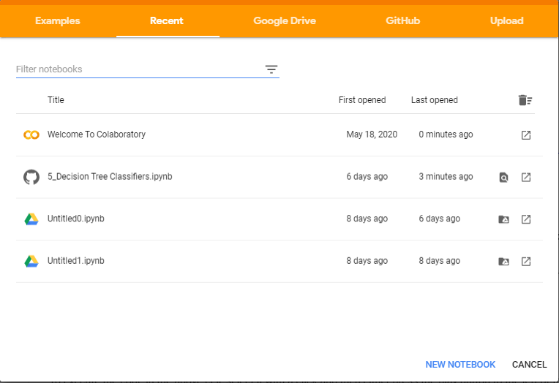

1. You will be using Notebooks stored on a Github repository. Click on the Github link.



1. Paste the following URL on the search bar:

[https://github.com/khider/INF549](https://github.com/khider/INF549/blob/master/Assignment3_MachineLearning/5_Decision%20Tree%20Classifiers.ipynb) and click enter.

This link should allow you access to all the notebooks on the repository.

Scroll down and select the notebook you need to complete your homework. You should be redirected to Jupyter Notebook.

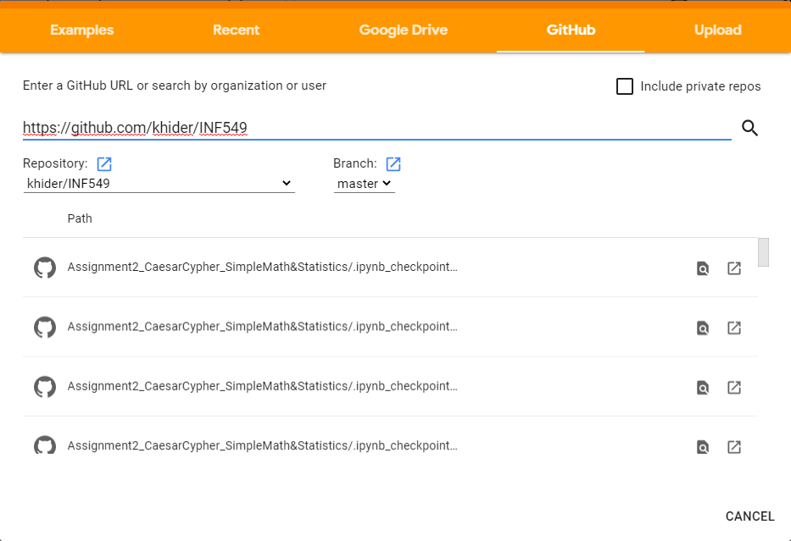

1. Click on the folder icon and wait a few seconds for the runtime to connect.

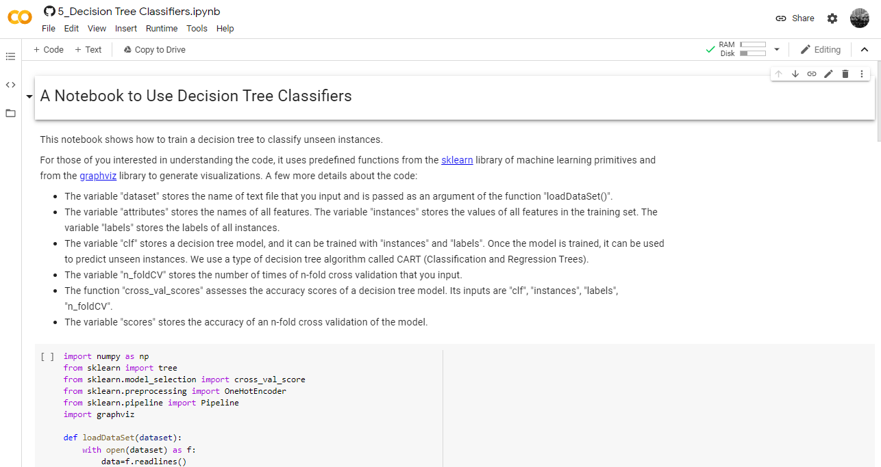

1. The sample data folder contains datasets populated automatically by Google Colab. **DO NOT USE FOR YOUR HOMEWORK.**
2. Some datasets are included as examples. To access them and download them into your Google Colab directory, run the corresponding cells in your notebook.
3. If you want to upload a file from your local computer, click on ‘Upload to session storage’ in the menu bar.

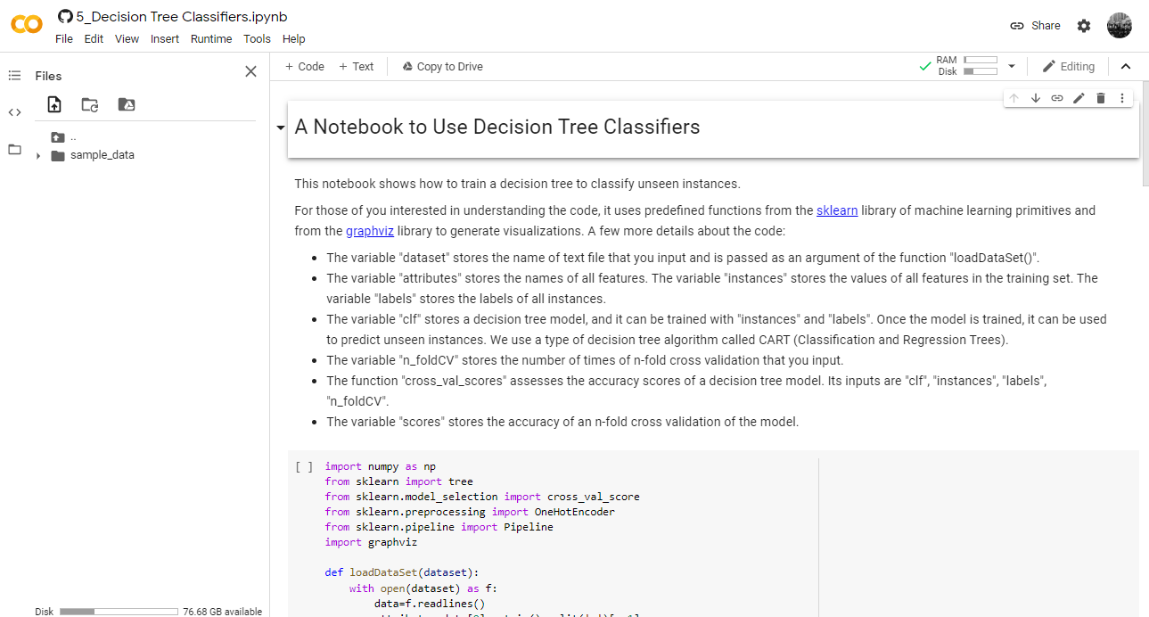

**Note:** Uploaded files are deleted after 12 hours. You might need to upload it again to use the file after 12 hours.

1. You can click on the Contents button to view and access any part of the notebook.

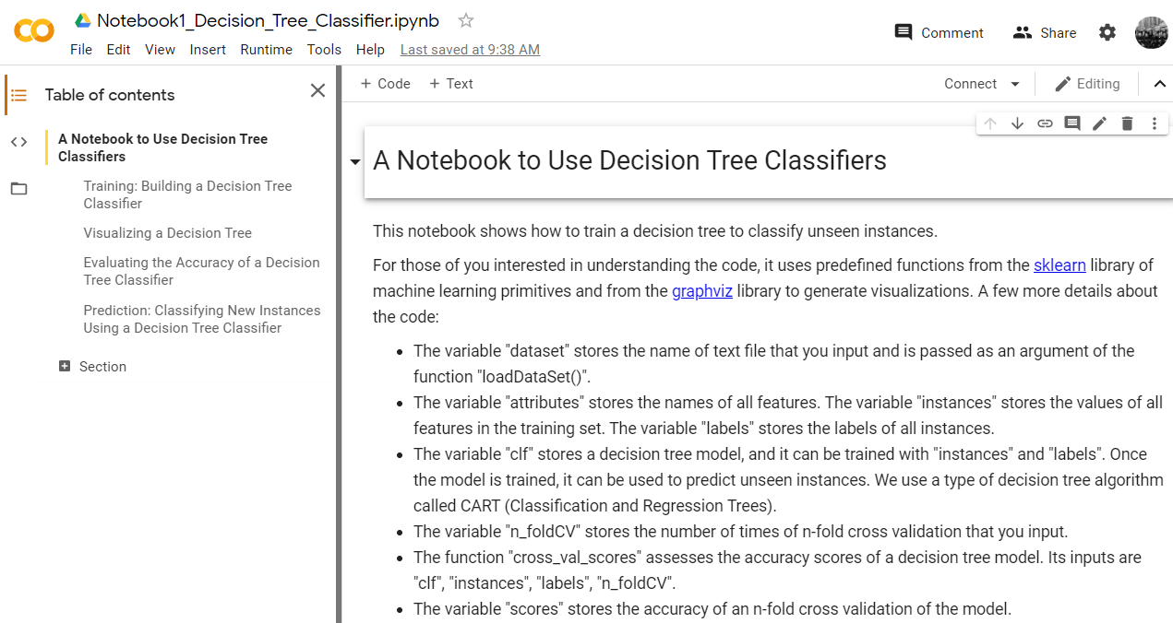

1. Use the notebooks to answer the questions given in the homework assignment.